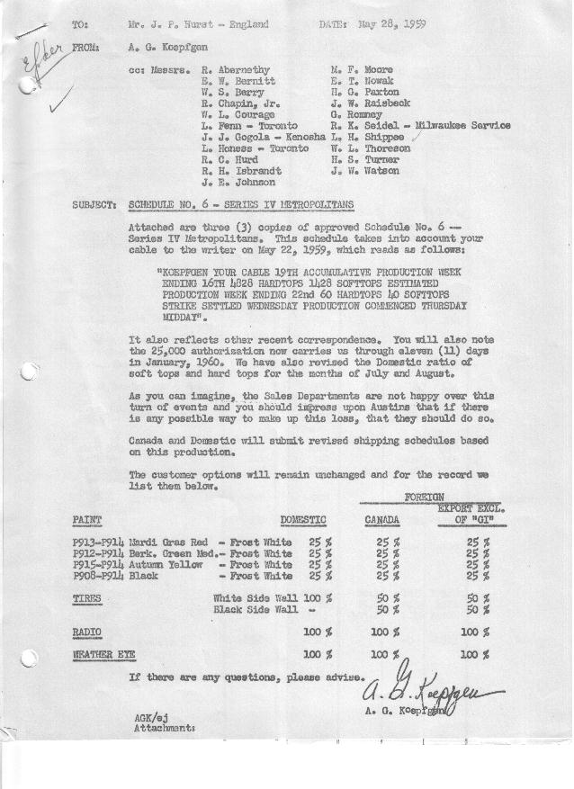

FORM AM 1262 Page 1 of 2 APPROVED R. Abernethy (signed) DATE 6-1-59

SCHEDULE NO. ______6 ___ DATE 5-27-59 MONTHLY BUILDING SCHEDULE APPROVED E.W.Bernitt (signed) DATE_ 6/2/59 _
REVISION NO. _______ __ ____ DATE PRODUCT APPROVED R. W.Chapin Jr. (signed) DATE _ 6/2/59 ____
SERIES IV 1500 c.c. ENGINE
METROPOLITAN SERIES CARS – AUSTIN MOTORS CO., LTD, ENGLAND
DESCRIPTION | BUILT  ◻ACT EST  THRU  May | FIRM BUILDING SCHEDULE  (FABRICATED MATERIAL RELEASE) |  |  |  |  |  |  |  |  |  |  |  |  |  |  | TENTATIVE SCHEDULE  (RAW MATERIAL RELEASED) |  |  | GRAND  TOTAL
DESCRIPTION | BUILT  ◻ACT EST  THRU  May | MONTH JUNE  DAYS 22 |  |  | MONTH JULY  DAYS 18 |  |  | MONTH AUGUST  DAYS 16 |  |  | MONTH SEPTEMBER  DAYS 22 |  |  | MONTH OCTOBER  DAYS 22 |  |  | MONTH NOVEMBER  DAYS 21 |  |  | GRAND  TOTAL
DESCRIPTION | BUILT  ◻ACT EST  THRU  May | DAILY | MONTH | CUM’L  TOTAL | DAILY | MONTH | CUM’L  TOTAL | DAILY | MONTH | CUM’L  TOTAL | DAILY | MONTH | CUM’L  TOTAL | DAILY | MONTH | CUM’L  TOTAL | DAILY | MONTH | CUM’L TOTAL | GRAND  TOTAL
DOMESTIC LHD:
Hard-Top | 4558 |  | 1774 | 6332 |  | 1740 | 8072 |  | 1552 | 9624 |  | 2318 | 11942 |  | 2276 | 14218 |  | 1667 | 15885
Soft-Top | 1465 |  | 576 | 2041 |  | 435 | 2476 |  | 388 | 2864 |  | 442 | 3306 |  | 434 | 3740 |  | 318 | 4058
Total U.S. | 6023 | 106.8 | 2350 | 8373 | 120.8 | 2175 | 10548 | 121.3 | 1940 | 12488 | 125.5 | 2760 | 15248 | 123.2 | 2710 | 17958 | 94.5 | 1985 | 19943
Over/(Under) Schedule 5 | (1815) |  | (300) | (2115) |  | -0- | (2115) |  | -0- | (2115) |  | -0- | (2115) |  | -0- | (2115) |  | -0- | (2115)
FOREIGN:
EXPORT LHD Hard-Top | 87 |  | 12 | 99 |  | 30 | 129 |  | 30 | 159 |  | 30 | 189 |  | 30 | 219 |  | 30 | 249
Soft-Top | 28 |  | 7 | 35 |  | 10 | 45 |  | 10 | 55 |  | 10 | 65 |  | 10 | 75 |  | 10 | 85
Total Export LHD | 115 |  | 19 | 134 |  | 40 | 174 |  | 40 | 214 |  | 40 | 254 |  | 40 | 294 |  | 40 | 334
RHD Hard Top | 19 |  | 12 | 31 |  | 7 | 38 |  | 7 | 45 |  | 7 | 52 |  | 7 | 59 |  | 15 | 74
Soft Top | 7 |  | 4 | 11 |  | 3 | 14 |  | 3 | 17 |  | 3 | 20 |  | 3 | 23 |  | 5 | 28
Total Export RHD | 26 |  | 16 | 42 |  | 10 | 52 |  | 10 | 62 |  | 10 | 72 |  | 10 | 82 |  | 20 | 102
Total Export LHD & RHD | 141 | 1.6 | 35 | 176 | 2.8 | 50 | 226 | 3.1 | 50 | 276 | 2.3 | 50 | 326 | 2.3 | 50 | 376 | 2.9 | 60 | 436
Over/(Under) Schedule 5 | -0- |  | -0- | -0- |  | -0- | -0- |  | -0- | -0- |  | -0- | -0- |  | -0- | -0- |  | -0- | -0-
CANADA Hard-Top | 571 |  | 146 | 717 |  | 115 | 832 |  | 90 | 922 |  | 50 | 972 |  | 100 | 1072 |  | 100 | 1172
Soft-Top | 121 |  | 29 | 150 |  | -0- | 150 |  | -0- | 150 |  | -0- | 150 |  | -0- | 150 |  | -0- | 150
Total Canada | 692 | 7.9 | 175 | 867 | 6.4 | 115 | 982 | 5.6 | 90 | 1072 | 2.2 | 50 | 1122 | 4.5 | 100 | 1222 | 4.7 | 100 | 1322
Over/(Under) Schedule 5 | (208) |  | -0- | (208) |  | -0- | (208) |  | -0- | (208) |  | -0- | (208) |  | -0- | (208) |  | -0- | (208)
Total Foreign | 833 | 9.5 | 210 | 1043 | 9.2 | 165 | 1208 | 8.7 | 140 | 1348 | 4.5 | 100 | 1448 | 6.8 | 150 | 1598 | 7.6 | 160 | 1758
Over/(Under) Schedule 5 | (208) |  | -0- | (208) |  | -0- | (208) |  | -0- | (208) |  | -0- | (208) |  | -0- | (208) |  | -0- | (208)
GRAND TOTALS
Hard-Top | 5235 | 88.4 | 1944 | 7179 | 105.1 | 1892 | 9071 | 104.9 | 1679 | 10750 | 109.3 | 2405 | 13155 | 109.7 | 2413 | 15568 | 86.3 | 1812 | 17380
Soft-Top | 1621 | 28.0 | 616 | 2237 | 24.9 | 448 | 2685 | 25.1 | 401 | 3086 | 20.7 | 455 | 3541 | 20.3 | 447 | 3988 | 15.8 | 333 | 4321
Total | 6856 | 116.4 | 2560 | 9416 | 130.0 | 2340 | 11756 | 130.0 | 2080 | 13836 | 130.0 | 2860 | 16696 | 130.0 | 2860 | 19556 | 102.1 | 2145 | 21701
Over/(Under) Schedule 5 | (2023) |  | (300) | (2323) |  | -0- | (2323) |  | -0- | (2323) |  | -0- | (2323) |  | -0- | (2323) |  | -0- | (2323)

FORM AM 1262 Page 2 of 2 APPROVED R. Abernethy (signed) DATE 6-1-59

SCHEDULE NO. ______6 ___ DATE 5-27-59 MONTHLY BUILDING SCHEDULE APPROVED E.W.Bernitt (signed) DATE_ 6/2/59 _
REVISION NO. _______ __ ____ DATE PRODUCT APPROVED R. W.Chapin Jr. (signed) DATE _ 6/2/59 ____
SERIES IV 1500 c.c. ENGINE
METROPOLITAN SERIES CARS – AUSTIN MOTORS CO., LTD, ENGLAND
DESCRIPTION | BUILT  ◻ACT◻ EST  THRU | FIRM BUILDING SCHEDULE  (FABRICATED MATERIAL RELEASE) |  |  |  |  |  |  |  |  |  |  |  |  |  |  | TENTATIVE SCHEDULE  (RAW MATERIAL RELEASED) |  |  | GRAND  TOTAL
DESCRIPTION | BUILT  ◻ACT◻ EST  THRU | MONTH DECEMBER  DAYS 21 |  |  | MONTH JANUARY ‘60  DAYS 11.3 |  |  | MONTH  DAYS |  |  | MONTH  DAYS |  |  | MONTH  DAYS |  |  | MONTH  DAYS |  |  | GRAND  TOTAL
DESCRIPTION | BUILT  ◻ACT◻ EST  THRU | DAILY | MONTH | CUM’L  TOTAL | DAILY | MONTH | CUM’L  TOTAL | DAILY | MONTH | CUM’L  TOTAL | DAILY | MONTH | CUM’L  TOTAL | DAILY | MONTH | CUM’L  TOTAL | DAILY | MONTH | CUM’L TOTAL | GRAND  TOTAL
DOMESTIC LHD:
Hard-Top |  |  | 1674 | 17559 |  | 972 | 18531
Soft-Top |  |  | 319 | 4377 |  | 182 | 4559
Total U.S. |  | 94.9 | 1993 | 21936 | 102.1 | 1154 | 23090
Over/(Under) Schedule 5 |  |  | 1017 | (1098) |  | 1154 | 56
FOREIGN:
EXPORT LHD Hard-Top |  |  | 30 | 279 |  | -0- | 279
Soft-Top |  |  | 10 | 95 |  | -0- | 95
Total Export LHD |  |  | 40 | 374 |  | -0- | 374
RHD Hard Top |  |  | 10 | 84 |  | -0- | 84
Soft Top |  |  | 2 | 30 |  | -0- | 30
Total Export RHD |  |  | 12 | 114 |  | -0- | 114
Total Export LHD & RHD |  | 2.5 | 52 | 488 | -0- | -0- | 488
Over/(Under) Schedule 5 |  |  | 52 | 52 |  | -0- | 52
CANADA Hard-Top |  |  | 100 | 1272 |  | -0- | 1272
Soft-Top |  |  | -0- | 150 |  | -0- | 150
Total Canada |  | 4.7 | 100 | 1422 | -0- | -0- | 1422
Over/(Under) Schedule 5 |  |  | 100 | (108) |  | -0- | (108)
Total Foreign |  | 7.2 | 152 | 1910 | -0- | -0- | 1910
Over/(Under) Schedule 5 |  |  | 152 | (56) |  | -0- | (56)
GRAND TOTALS
Hard-Top |  | 86.3 | 1814 | 19194 | 86.0 | 972 | 20166
Soft-Top |  | 15.8 | 331 | 4652 | 16.1 | 182 | 4834
Total |  | 102.1 | 2145 | 23846 | 102.1 | 1154 | 25000
Over/(Under) Schedule 5 |  |  | 1169 | (1154) |  | 1154 | -0-

